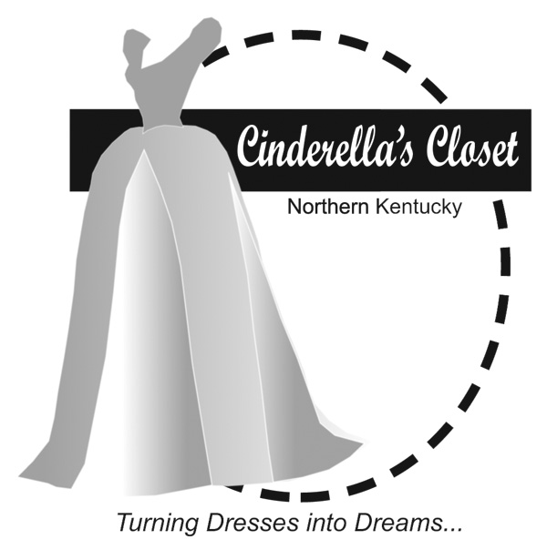

**How can you help?**

* **DONATE** *(all donations are tax deductible)*
  + Donate gently used or new formal gowns, shoes, purses and jewelry
  + Make a monetary donation to help purchase items not donated in the quantities needed (i.e. plus size dresses and shoes)
* **VOLUNTEER**
  + Organize a dress drive at your school, work or church
  + Host a Cinderella’s Closet party to collect dresses and accessories
  + Be a Fairy Godmother and work one on one with our princesses to find the dress of their dreams (ladies age 20 or older)
  + Make a commitment to be on our organizing committee

**Find out more about this ministry:**

**www.cinderellasclosetpac.com**

**On Facebook: Cinderella’s Closet Purchase Area Community**

**or call 270.556.2682**

***TURNING DRESSES INTO DREAMS***

Cinderella's Closet provides formal wear to girls who could not otherwise attend their prom. Through donations of new and gently used formal dresses and accessories, Cinderella’s Closet is able to "Turn Dresses Into Dreams." Cinderella’s Closet originated in Northern Kentucky, and now we have continued this ministry in the Jackson Purchase Area. Junior and senior girls in McCracken County, Carlisle County, Graves County, Hickman County, Ballard County, Marshall County, Union County, Lyon County, Livingston County, Calloway County and Vienna, IL will be referred to our organization by their school. Even more than a dress, Cinderella's Closet provides an unforgettable, amazing experience.  From the moment our princesses walk through our doors, they are greeted with an environment of grace, love and respect.  It is our mission that they leave knowing they are cherished. We look forward to ***Turning Dresses Into Dreams*** on March 18 2023.

Cinderella’s Closet

Purchase Area Community

Turning Dresses Into Dreams