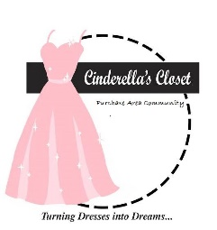 Cinderella’s Closet

Purchase Area Community

*UK BASKETBALL TICKET RAFFLE*

 

**FRIDAY NOVEMBER 9, 2018**

**UK VERSUS SIU**

**HERE’S YOUR CHANCE TO SEE THE UK WILDCATS PLAY AT RUPP ARENA**

**TWO LOWER LEVEL SEATS**

**Raffle tickets $10.00 Each   
Buy 3 for $25.00**

**Only 440 tickets will be sold.**

100% of the proceeds benefit

Cinderella’s Closet Purchase Area Community

Cinderella's Closet provides formal wear to girls who could not otherwise attend their prom. Through donations of new and gently used formal dresses and accessories, we are able to "Turn Dresses Into Dreams" for juniors and seniors referred to our organization by their school or social care agency. Even more than a dress, Cinderella's Closet provides an unforgettable, amazing experience. From the moment our princesses dance through our doors they are greeted with an environment of grace, love and respect. It is our mission that they leave knowing they are cherished. On **March 17, 2018, Cinderella’s Closet of the Purchase Area Community helped approximately 80 girls find the Dress of their Dreams. Be a Part of Something Truly Special – Turning Dresses Into Dreams**

Tickets Available by calling Susan Kirkham 270.556.2682 or email cinderellasclosetpac@gmail.com

Information also available at Cinderellasclosetpac.com

Make checks to: Cinderella’s Closet. Memo UK raffle

Drawing Date: October 26, 2018, 2:00 P.M.

**Turning Dresses Into Dreams**