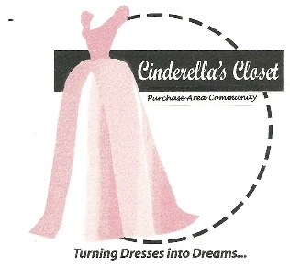
Cinderella’s Closet
Purchase Area Community
Boxed Lunch Sale
100% of the proceeds benefit Cinderella’s Closet Purchase Area Community
FRIDAY OCTOBER 28, 2016
PRICE $10/LUNCH

Each Lunch Includes:
Fabulous Chicken Salad,
Croissant, Chips, Brownie

And a chance to win a Door Prizes

Delivery Available
For orders of 10 or more in McCracken County.

Pick-up Orders Available
Between 9:30am and 12:30pm at Immanuel Baptist Church
3465 Buckner Ln.
Paducah, KY

Cinderella's Closet provides formal wear to girls who could not otherwise attend their prom. Through donations of new and gently used formal dresses and accessories, we are able to "Turn Dresses Into Dreams" for juniors and seniors referred to our organization by their school or social care agency. Even more than a dress, Cinderella's Closet provides an unforgettable, amazing experience. From the moment our princesses dance through our doors they are greeted with an environment of grace, love and respect. It is our mission that they leave knowing they are cherished. Spring 2017, Cinderella’s Closet of the Purchase Area Community plans to help approximately 100 girls find the Dress of their Dreams. Be A Part of Something Truly Special – Turn Dresses Into Dreams

Order Form Available:
Cinderellasclosetpac.com
FB Cinderella’s Closet Purchase Area Community

Contact: 270.556.2682 if you have questions.

Cinderella’s Closet is a ministry of Immanuel Baptist Church, Paducah, KY

