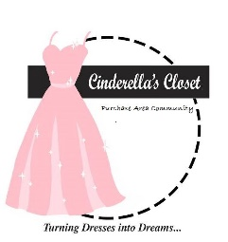
Cinderella’s Closet
Purchase Area Community
Boxed Lunch Sale

FRIDAY OCTOBER 26, 2018
$10/LUNCH
Order by NOON October 24

Each Lunch Includes:
Fabulous Homemade Chicken Salad,
Croissant, Pickle, Chips, Brownie

Delivery Available
For pre-orders of 10 or more in Paducah/McCracken County.
Pre-ordered lunches of 9 or less
May be picked up between 9:30am and 12:30pm at
Immanuel Baptist Church
3465 Buckner Ln.
Paducah, KY

100% of the proceeds benefit Cinderella’s Closet Purchase Area Community

Cinderella's Closet provides formal wear to girls in the Purchase Area who could not otherwise attend their prom. Through donations of new and gently used formal dresses and accessories, we are able to "Turn Dresses Into Dreams" for juniors and seniors referred to our organization by their school or social care agency. Even more than a dress, Cinderella's Closet provides an unforgettable, amazing experience. From the moment our princesses dance through our doors they are greeted with an environment of grace, love and respect. It is our mission that they leave knowing they are cherished. On March 17, 2018, Cinderella’s Closet of the Purchase Area Community helped approximately 80 girls in the Purchase Area find the Dress of their Dreams. Be A Part of Something Truly Special – Turning Dresses Into Dreams

Order Form Available: at Cinderellasclosetpac.com

Contact: 270.556.2682 if you have questions.

Cinderella’s Closet is a ministry of Immanuel Baptist Church, Paducah, KY

Turning Dresses Into Dreams
Cinderella’s Closet is also selling Raffle Tickets to the November 9 University of Kentucky Basketball game. They may be purchased by calling 270.556.2682 or emailing cinderellasclosetpac@gmail.com. Only 440 tickets will be sold.

