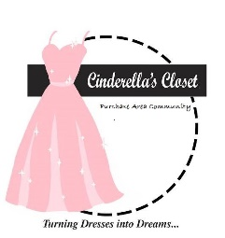
Cinderella’s Closet
Purchase Area Community
Boxed Lunch Sale
Delivery Available
For orders of 10 or more in Paducah/McCracken County.
Pre-ordered lunches of 9 or less
May be picked up between 9:30am and 12:30pm at
Immanuel Baptist Church
3465 Buckner Ln.
Paducah, KY

100% of the proceeds benefit Cinderella’s Closet Purchase Area Community
FRIDAY OCTOBER 27, 2017
$10/LUNCH

Each Lunch Includes:
Fabulous Chicken Salad,
Croissant, Chips, Brownie

And a chance to win a Door Prize

Cinderella's Closet provides formal wear to girls who could not otherwise attend their prom. Through donations of new and gently used formal dresses and accessories, we are able to "Turn Dresses Into Dreams" for juniors and seniors referred to our organization by their school or social care agency. Even more than a dress, Cinderella's Closet provides an unforgettable, amazing experience. From the moment our princesses dance through our doors they are greeted with an environment of grace, love and respect. It is our mission that they leave knowing they are cherished. March 17, 2018, Cinderella’s Closet of the Purchase Area Community plans to help approximately 100 girls find the Dress of their Dreams. Be A Part of Something Truly Special – Turn Dresses Into Dreams

Order Form Available:

Cinderellasclosetpac.com

Contact: 270.556.2682 if you have questions.

Cinderella’s Closet is a ministry of Immanuel Baptist Church, Paducah, KY

Turn Dresses Into Dreams

